‘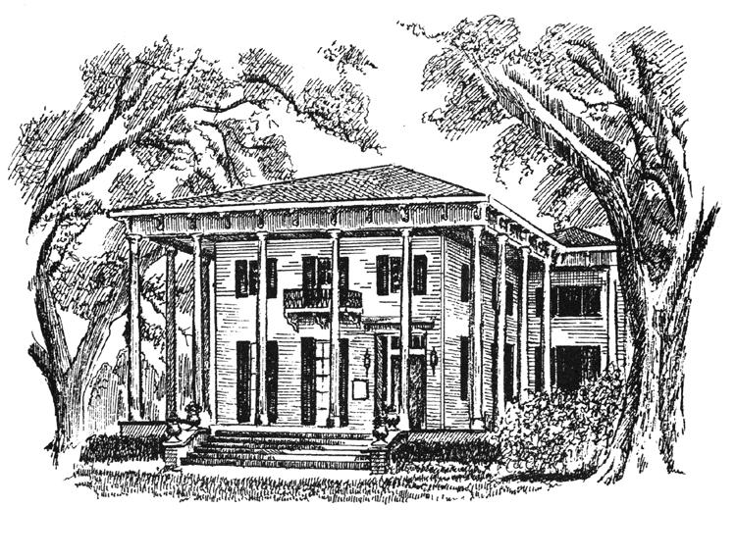

THE BRAGG-MITCHELL MANSION
Tour & Tea Room Basket Lunch

Your group of 20 or more guests can enjoy lunch in one of our beautiful tea rooms before or after your tour. Rate includes lunch, tour. Groups of 25 or more are subject to an additional service fee.
Price is subject to all applicable taxes.

$24 per person
Each lunch includes your choice of sandwich, side, chips, cookie, and iced tea.

Club Sandwich
Ham and Swiss on Kaiser Roll
Gourmet Chicken Salad on Croissant

Side Choices
Gourmet Potato Salad, Italian Pasta Toss, Creole Cole Slaw, Fresh Fruit Salad

All sandwiches come with chips and dessert.

Iced tea is offered both sweetened and unsweetened.

.

The final guest count is required one (1) week in advance. Deposit will be calculated and required at time of booking. Cancellations must be made 72 hours prior to the event or cancellation fees will apply.

GUEST NAME ______________________________________________________________________

Sandwich Selection (circle one)
Naman’s Club Sandwich Ham and Swiss Chicken Salad Croissant

Side Selection (circle one)
Potato Salad Cole Slaw Pasta Salad Fruit Salad

Sandwich Selection (circle one)
Club Chicken Salad Veggie Wrap Roast Beef Shrimp Salad

Side Selection (circle on)
Potato Salad Cole Slaw Garden Salad Pasta Salad Caesar Salad Fruit Salad

Dessert (circle one)
Cookie Brownie

GUEST NAME _________________________________ _____________________________________

Sandwich Selection (circle one)
Club Chicken Salad Veggie Wrap Roast Beef Shrimp Salad

Side Selection (circle on)
Potato Salad Cole Slaw Garden Salad Pasta Salad Caesar Salad Fruit Salad

Dessert (circle one)
Cookie Brownie

GUEST NAME _________________________________ _____________________________________

Sandwich Selection (circle one)
Club Chicken Salad Veggie Wrap Roast Beef Shrimp Salad

Side Selection (circle on)
Potato Salad Cole Slaw Garden Salad Pasta Salad Caesar Salad Fruit Salad

Dessert (circle one)
Cookie Brownie

GUEST NAME _________________________________ _____________________________________

Sandwich Selection (circle one)
Club Chicken Salad Veggie Wrap Roast Beef Shrimp Salad

Side Selection (circle on)
Potato Salad Cole Slaw Garden Salad Pasta Salad Caesar Salad Fruit Salad

Dessert (circle one)
Cookie Brownie

GUEST NAME _________________________________ _____________________________________

Sandwich Selection (circle one)
Club Chicken Salad Veggie Wrap Roast Beef Shrimp Salad

Side Selection (circle on)
Potato Salad Cole Slaw Garden Salad Pasta Salad Caesar Salad Fruit Salad

Dessert (circle one)
Cookie Brownie

GUEST NAME ______________________________________________________________________

Sandwich Selection (circle one)
Naman’s Club Sandwich Ham and Swiss Chicken Salad Croissant

Side Selection (circle one)
Potato Salad Cole Slaw Pasta Salad Fruit Salad

GUEST NAME _________________________________ _____________________________________

Sandwich Selection (circle one)
Club Chicken Salad Veggie Wrap Roast Beef Shrimp Salad

Side Selection (circle on)
Potato Salad Cole Slaw Garden Salad Pasta Salad Caesar Salad Fruit Salad

Dessert (circle one)
Cookie Brownie

GUEST NAME _________________________________ _____________________________________

Sandwich Selection (circle one)
Club Chicken Salad Veggie Wrap Roast Beef Shrimp Salad

Side Selection (circle on)
Potato Salad Cole Slaw Garden Salad Pasta Salad Caesar Salad Fruit Salad

Dessert (circle one)
Cookie Brownie

GUEST NAME _________________________________ _____________________________________

Sandwich Selection (circle one)
Club Chicken Salad Veggie Wrap Roast Beef Shrimp Salad

Side Selection (circle on)
Potato Salad Cole Slaw Garden Salad Pasta Salad Caesar Salad Fruit Salad

Dessert (circle one)
Cookie Brownie

GUEST NAME ______________________________________________________________________

Sandwich Selection (circle one)
Naman’s Club Sandwich Ham and Swiss Chicken Salad Croissant

Side Selection (circle one)
Potato Salad Cole Slaw Pasta Salad Fruit Salad

