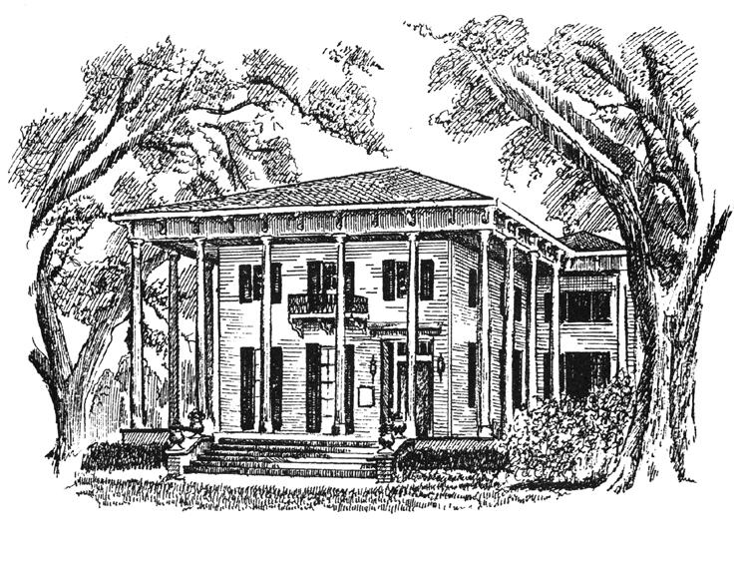

THE BRAGG-MITCHELL MANSION

Afternoon Tea
$26.50 person

Your group of 20 or more can enjoy afternoon tea including: hot/cold tea, assorted finger sandwiches and desserts, cheese straws and fruit, in one of our tea rooms before or after your tour. Rates include tea and tour. Groups of 25 or more are subject to an additional service fee.
Price is subject to all applicable taxes.
The final guest count is required one (1) week in advance. A deposit will be calculated and required at time of booking. Cancellations must be made 72 hours prior to the event or cancellation fees will apply.

